**1.1 INTRODUCTION:-**

[Transformers](https://www.electrical4u.com/what-is-transformer-definition-working-principle-of-transformer/) are electromagnetic devices which transform alternating current (AC) electrical energy from primary to secondary side. The energy is transformed with equal frequency and approximately equal power by means of the transformer core magnetic field. Thus they provide galvanic isolation in the electrical system. The isolation transformers operate in the same way as other transformer types. But the main task is to provide the galvanic isolation in the electrical system. They can work as [step-up transformer](https://www.electrical4u.com/step-up-transformer/) or [step-down transformers](https://www.electrical4u.com/step-down-transformers/) but often operate with turn’sratioN1/N2 = 1. This means that the primary and secondary voltage values are equal. This is obtained with an same number of turns on the primary and secondary windings.

An isolation transformer is a [transformer](https://en.wikipedia.org/wiki/Transformer) used to transfer [electrical power](https://en.wikipedia.org/wiki/Electrical_power) from a source of [alternating current](https://en.wikipedia.org/wiki/Alternating_current) (AC) power to some equipment or device while isolating the powered device from the power source, usually for safety reasons. Isolation transformers provide [galvanic isolation](https://en.wikipedia.org/wiki/Galvanic_isolation) and are used to protect against [electric shock](https://en.wikipedia.org/wiki/Electric_shock), to suppress electrical noise in sensitive devices, or to transfer power between two circuits which must not be connected. A transformer sold for isolation is often built with special insulation between primary and secondary, and is specified to withstand a high voltage between windings.

Isolation transformers block transmission of the DC component in signals from one circuit to the other, but allow AC components in signals to pass. Transformers that have a ratio of 1 to 1 between the primary and secondary windings are often used to protect secondary circuits and individuals from electrical shocks between energized conductors and earth ground. Suitably designed isolation transformers block interference caused by [ground loops](https://en.wikipedia.org/wiki/Ground_loop_(electricity)). Isolation transformers with electrostatic shields are used for power supplies for sensitive equipment such as computers, medical devices, or laboratory instruments.

The **isolation transformers** are used in many electrical devices as computers, measurement devices or specific industry power electronic devices.

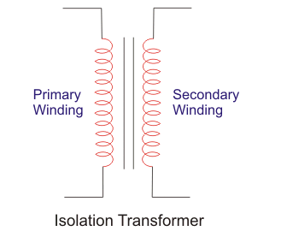

Fig.1.1. isolation transformer

It is very important to use isolating transformers when an oscilloscope measures signals in an electrical circuit which is not galvanic ally isolated from the network. Because the current circuit can be closed (short-circuited) between oscilloscope common point and grounding. The main purpose of the isolation transformer is safety and protection of electronic components and the persons against electrical shock. It physically separates the power supplying from primary side and a secondary side circuit connected to electronic components and grounded metal parts which are in contact with the person. Basically, the transformer secondary side is isolated from the grounding.

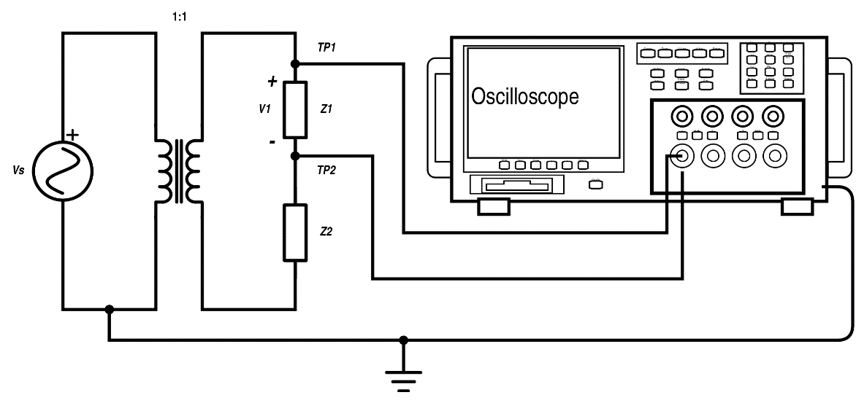

Fig.1.2. isolation transformer connected to CRO

This means that the isolation transformer secondary side must not be grounded. It would create a physical connection between the primary and secondary transformer side. The auto transformer with common winding cannot be used as **isolation transformer** because it has a connection between primary and secondary side. Isolation transformer provides available supplying even if the device is broken. The primary side remains under [voltage](https://www.electrical4u.com/voltage-or-electric-potential-difference/) which can be used to supply some alarm or warning beep circuits when the device is broken. The transformers suppress the electrical noise from supplying or electromagnetic induction. That is very important in case of sensitive devices as measurement or medical devices. This transformer is built with electrostatic shields which additionally increase the electrical noise suppression. The proper isolation transformer design avoids ground loops. Ground loops create an additional [current](https://www.electrical4u.com/electric-current-and-theory-of-electricity/) path where the current created by electromagnetic induction can flow. This is the main reason for noise and interference in the signal.

When the isolation transformer is designed it is very important to pay attention to windings capacitance values which create capacitive coupling. This enables AC signal to pass from primary to the secondary side which significantly increased the noise level. For this purpose, the windings are surrounded by a metal strip which is grounded (creating a Faraday shield). The **isolationtransformers**are used as [instrument transformers](https://www.electrical4u.com/instrument-transformers/) when the high voltage should be measured. The high voltage is dangerous for the person who tries to measure high voltage but it can also harm the measurement circuits. In this case, the step-down isolation transformer is used to reduce the high voltage to the safe level and for measurement range.

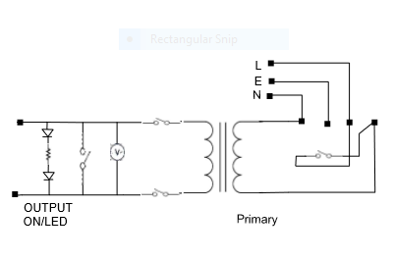

**Fig.1.3.circuit diagram**

**In this Project we designed an Isolation Transformer of rating 500VA, voltage ratio 230V/230V which will helps to isolate equ**ipment for ex CRO used in our lab. It will be also useful to conduct experiments in our department lab.

Mainly Isolation transformer is used to

* Protect Users From Faulty Equipment
* Enable Safe And Accurate Measurements
* Avoid Ground Loop
* Physically separate one part of an electrical system from another

**2.1 WORKING:-**

* **ISOLATION TRANSFORMER CONSTRUCTION:-**

Transformers can be described as two coils surrounding a core of ferromagnetic material, as shown in Figure.

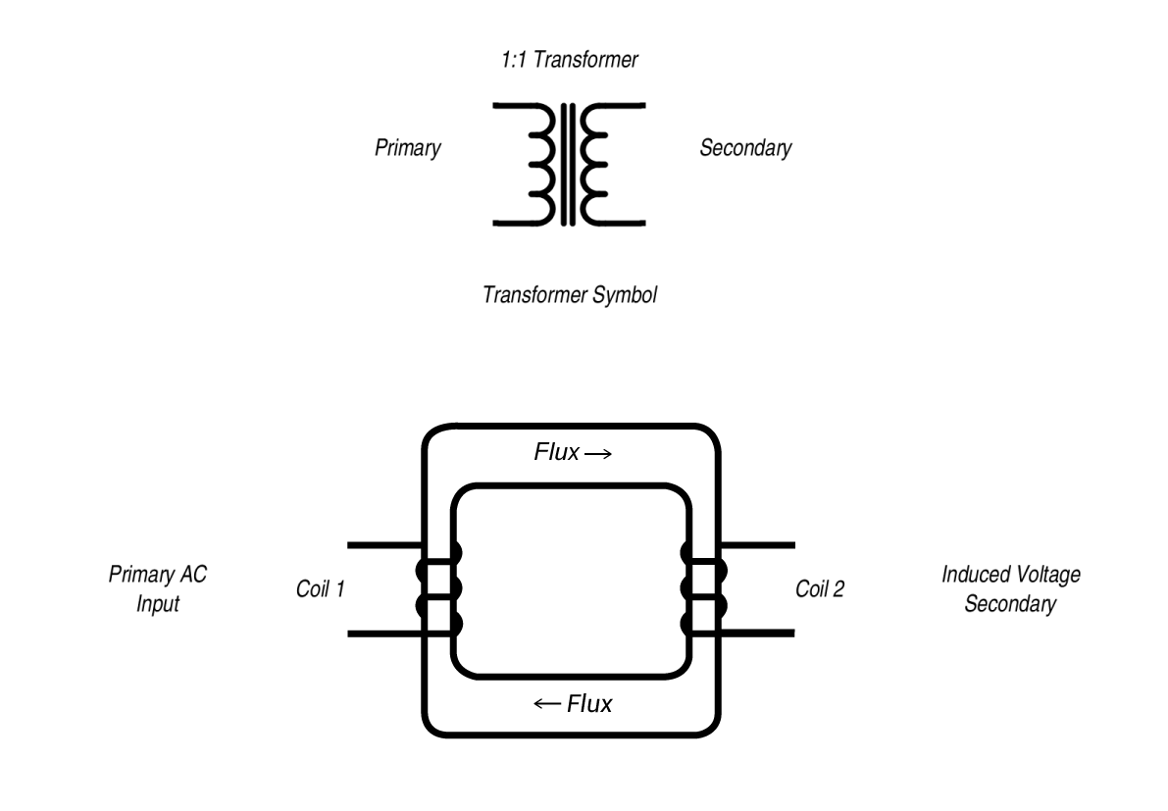

Fig.2.1. CONSTRUCTION

The schematic representation shows the primary and secondary coils; the electric source is connected to the primary, the isolated output is taken from the secondary. The coils are physically separate from each other and the core.  Michael Faraday first used an early transformer during his experiments investigating electromagnetism. Faraday found that a wire carrying a current induces a magnetic field surrounding the wire and that when two separate wires were coiled around a toroid of soft iron, a current in one induced a magnetic field, and the changing flux in turn induced a voltage in the other.  Now known as mutual induction, Faraday is credited with discovering that an electromotive force is induced in a circuit by a changing magnetic flux according to the formula:

E=−dΦBdtE=−dΦBdt

Sometimes this is shown using the absolute value of E:

|E|=dΦBdt|E|=dΦBdt

The negative indicating the electromotive force opposes the current.

Because Faraday was working with DC voltage, he only saw the effect of electromagnetic induction when a battery was initially connected or disconnected to the circuits, when the magnetic flux was changing.  With AC power connected to the primary, the varying current creates a varying magnetic field, the magnetic flux is realized in the core, and that in turn induces a voltage the secondary, with no electrical path between the two coils. The inductive coupling provided by the changing magnetic flux between the two coils allows communication across transformer. The magnetic field induced by a transformer depends on the number of turns/unit length of the windings, the permittivity of the magnetic core, and the current magnitude. The first commercially viable transformer was invented by William Stanley, working for George Westinghouse in the 1880s.

Although any transformer consisting of two separate coils and no grounding shields provide isolation, the term isolation transformer applies to transformers especially designed for the purpose of providing electrical isolation; whose primary purpose is to isolate an AC source from circuits, devices and equipment.  The design of an isolation transformer takes into account anything that may couple the primary and secondary windings. They often have special insulation between the primary and secondary coils, and are specified to withstand high voltage between windings. Because power line/transient voltage noise can be coupled thru the capacitance and resistive paths of the coils, isolation transformers have additional features to reduce common-mode noise (occurring on both the hot and neutral wires referenced to ground), transverse mode noise (occurring between the hot and neutral wires) and electromagnetic noise. DC signals are blocked by the transformer as well as interference caused by ground loops. For sensitive equipment (computers or measuring instruments) electrostatic shields are included to reduce any capacitance between the windings.

Isolation transformers used for safety usually have a turns ration of 1:1, with the number turns in the primary and secondary windings equal, but step-up and step-down isolation transformers are used when the voltage also needs to be changed.  When choosing an isolation transformer, check the specs for the features included, the ratings and how they are constructed.

### **WINDING:-**

### While some isolation transformers produce output voltage which is identical to their input - known as **1:1 transformers** - others feature proportionately wound coils to allow multiplication or division of the input voltage. Of these types, **step uptransformers**produce output voltages greater than their input, while **step down** devices produce smaller outputs relative to their input.

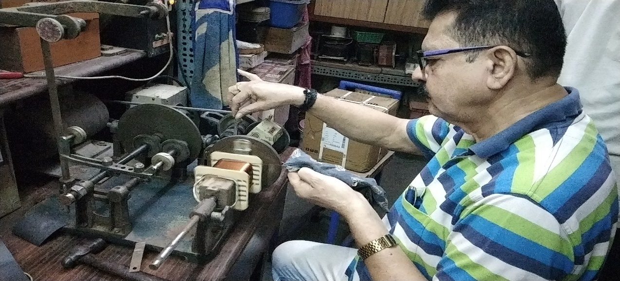

Fig.2.2.winding

### The two images below illustrate examples of step up and step down transformers. Note that in both cases the output voltage varies proportionately to the number of coil windings. For example, because the step down transformer's secondary coil winding is at a 1:5 (or 1/5) ratio to its primary winding, the output voltage will be 1/5 the voltage of the input. For this reason, the buyer may want to specify the **number of windings** for the primary and/or secondary coil. It is also important to note that, while these two transformers alter the output voltage and current relative to the number of windings, the power (in watts) remains constant across the two circuits.

### **PHASE:-**

### Isolation transformers may be manufactured to be compatible with single-phase or three-phase AC power.

### Single-phase power refers to AC systems where voltages fluctuate in unison. Single-phase AC is cheap to install and operate but is not powerful enough to supply large motors and other industrial equipment. Three-phase power uses three different signals which peak at varying times. Using three separate signals eliminates the fluctuations inherent in a single-phase system. When used to power large motors, three-phase power results in less vibration and simpler equipment design.

**2.2 SPECIAL PURPOSE ISOLATION TRANSFORMERS:-**

* **Isolation transformers have been developed for specialized applications.  Some examples are:-**
* **Pulse transformers:** optimized for transmitting rectangular electrical pulses and provide electrical isolation for digital signals. These are used in computer networks.
* **Austin transformers**: invented by Arthur O. Austin, these power the air-traffic obstacle lamps you see on an antenna structures. If not isolated, the lighting circuitry on the antenna mast would conduct radio-frequency energy to ground. These transformers also completely isolate the building AC mains from the tower.
* **Instrument transformers**: to supply precise voltage for meters and are used to safely isolate control circuitry from high voltages/currents. The primary winding of the transformer is connected to the high voltage/current circuit and the meter is connected to the secondary circuit much like the connections.

Note: Some transformers are made with only one winding which is tapped at different places on the winding to divide it into primary and secondary portions. Known as auto-transformers, these devices do not provide isolation, as the single winding is shared. Isolation transformers have separate coils, with no physical connection between the coils, no earth ground.

**2.3 TRANSFORMER BASICS:-**

Transformers are electrical devices consisting of two or more coils of wire used to transfer electrical energy by means of a changing magnetic field

One of the main reasons that we use alternating AC voltages and currents in our homes and workplace’s is that AC supplies can be easily generated at a convenient voltage, transformed (hence the name transformer) into much higher voltages and then distributed around the country using a national grid of pylons and cables over very long distances.

The reason for transforming the voltage to a much higher level is that higher distribution voltages implies lower currents for the same power and therefore lower I2*R losses along the networked grid of cables. These higher AC transmission voltages and currents can then be reduced to a much lower, safer and usable voltage level where it can be used to supply electrical equipment in our homes and workplaces, and all this is possible thanks to the basic **Voltage Transformer**.

* **A TYPICAL VOLTAGE TRANSFORMER:-**

The **Voltage Transformer** can be thought of as an electrical component rather than an electronic component. A transformer basically is very simple static (or stationary) electro-magnetic passive electrical device that works on the principle of Faraday’s law of induction by converting electrical energy from one value to another.

The transformer does this by linking together two or more electrical circuits using a common oscillating magnetic circuit which is produced by the transformer itself. A transformer operates on the principals of “electromagnetic induction”, in the form of Mutual Induction.

Mutual induction is the process by which a coil of wire magnetically induces a voltage into another coil located in close proximity to it. Then we can say that transformers work in the “magnetic domain”, and transformers get their name from the fact that they “transform” one voltage or current level into another.

Transformers are capable of either increasing or decreasing the voltage and current levels of their supply, without modifying its frequency, or the amount of electrical power being transferred from one winding to another via the magnetic circuit.

A single phase voltage transformer basically consists of two electrical coils of wire, one called the “Primary Winding” and another called the “Secondary Winding”. For this tutorial we will define the “primary” side of the transformer as the side that usually takes power, and the “secondary” as the side that usually delivers power. In a single-phase voltage transformer the primary is usually the side with the higher voltage.

These two coils are not in electrical contact with each other but are instead wrapped together around a common closed magnetic iron circuit called the “core”. This soft iron core is not solid but made up of individual laminations connected together to help reduce the core’s losses.

The two coil windings are electrically isolated from each other but are magnetically linked through the common core allowing electrical power to be transferred from one coil to the other. When an electric current passed through the primary winding, a magnetic field is developed which induces a voltage into the secondary winding.

**2.4 APPLICATIONS OR PURPOSE:-**

1. to isolate & protect sensitive equipment’s from electrical system ground
2. to protect delicate & expensive equipment’s from voltage spark
3. There is also some special **application of isolating transformers**, such us pulse transformers which transmit rectangular pulse signals and provide the electrical isolation. This type is suitable in some computer network designs.

### **STANDARDS / APPROVALS:-**

### Isolation transformers may be manufactured to various quality standards. This is especially important for medical transformers, as medical device failure may have fatal consequences when used in hospitals and other medical applications.

**2.5 ADVANTAGES:-**

1. What is Transformer Transformers are electrical devices used to convert or "transform" AC voltage from one level to another. Input and output voltage are AC. Transformer are working on principle of electromagnetic induction.
2. Limitation of Normal Transformer There is no isolation between the primary winding and the secondary winding. Therefore protection of the equipment is dependent on the supply devices. The primary and secondary winding share a common end. A failure of the winding insulation result of this full input voltage applied to the output. These are some limitation of normal transformers so that Isolation transformer comes in picture.
3. Isolation Transformer Isolation transformers define as primary (input) and secondary (output) windings separated from each other. In this type of transformer the input power and the output power are electrically separated by an dielectric insulation barrier.
4. The Advantages of an Isolation Transformer Safety Reduces Surges Noise Reduction Better Power Quality
5. Safety Protect Medical Equipment Protect Human to electric Shock Protect costly
6. home appliances Increase Quality of current
7. Reduces Surges another advantage of isolation transformers is that they reduce power surges. Electrical equipment can run smoothly without the risk of power surges. The DC signals from a power source are isolated.
8. Noise Reduction Isolation Transformer are specially designed for reduce noise from power lines by separate Faraday shields .These shields help to block electric fields from interrupting the power flow. For this reason less electromagnetic noise involved with output current.

* **USE OF AN ISOLATING (ISOLATION) TRANSFORMER:-**

A safe working practice which is effective is to isolate the supply from earth. If this is done, the connected appliance may be used in wet or damp situations, indoors or outdoors, and may be used on appliances to work on exposed earthed metal.

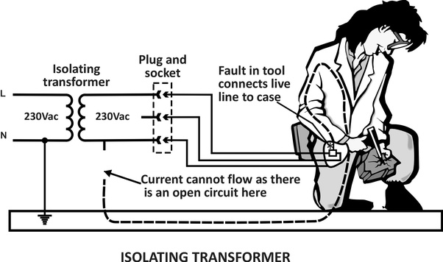

Fig.2.3 use of isolation transformer

Transformer itself is earthed, is sited in a dry environment, and connected to the supply via a short, earthed connector. The connected tool or appliance will be effectively isolated from earth. Should the user come in contact with any part of the appliance electrical circuit, there will be no return path through the person, and no hazard exists.

For maximum safety, only one appliance should be used from a single secondary winding. Two appliances may be plugged in, but their frames should be bonded together but not earthed. So if both appliances develop faults, there will not be a potential difference between their frames, but the short circuit created will clear the upstream fuse or circuit breaker.

**2.6 TRANSFORMER DESIGN:-**

A simple two-winding transformer construction consists of each winding being wound on a separate soft iron limb or core which provides the necessary magnetic circuit

This magnetic circuit, know more commonly as the “transformer core” is designed to provide a path for the magnetic field to flow around, which is necessary for induction of the voltage between the two windings.

However, this type of transformer construction where the two windings are wound on separate limbs is not very efficient since the primary and secondary windings are well separated from each other. This results in a low magnetic coupling between the two windings as well as large amounts of magnetic flux leakage from the transformer itself. But as well as this “O” shapes construction, there are different types of “transformer construction” and designs available which are used to overcome these inefficiencies producing a smaller more compact transformer.

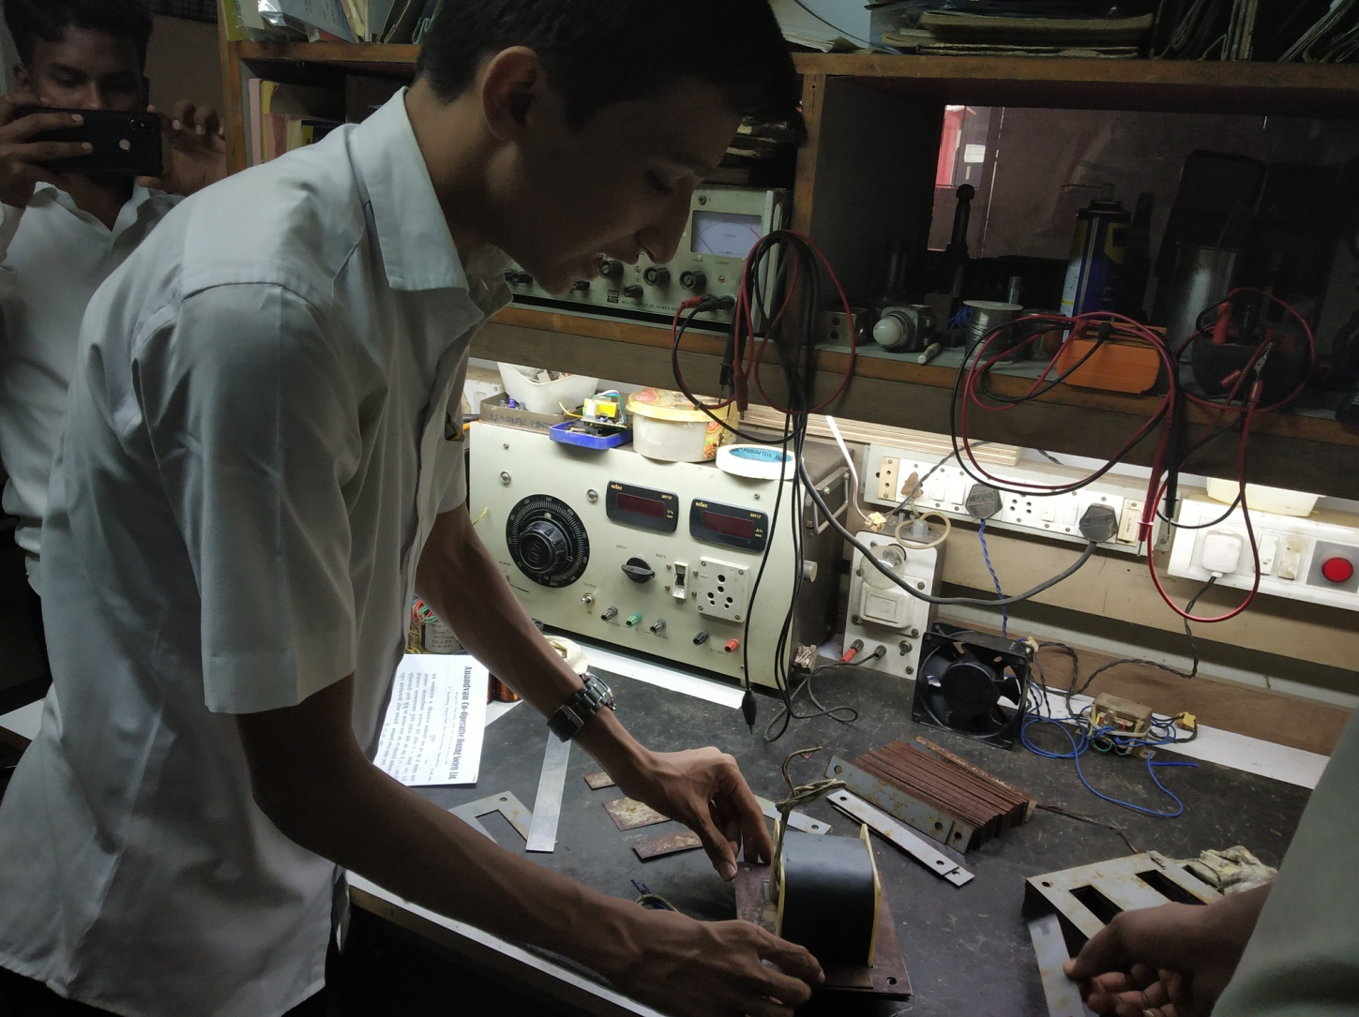

Fig.2.4 stamping process

The efficiency of a simple transformer construction can be improved by bringing the two windings within close contact with each other thereby improving the magnetic coupling. Increasing and concentrating the magnetic circuit around the coils may improve the magnetic coupling between the two windings, but it also has the effect of increasing the magnetic losses of the transformer core.

As well as providing a low reluctance path for the magnetic field, the core is designed to prevent circulating electric currents within the iron core itself. Circulating currents, called “eddy currents”, cause heating and energy losses within the core decreasing the transformers efficiency.

These losses are due mainly to voltages induced in the iron circuit, which is constantly being subjected to the alternating magnetic fields setup by the external sinusoidal supply voltage. One way to reduce these unwanted power losses is to construct the transformer core from thin steel laminations.

In all types of transformer construction, the central iron core is constructed from of a highly permeable material made from thin silicon steel laminations. These thin laminations are assembled together to provide the required magnetic path with the minimum of magnetic losses. The resistivity of the steel sheet itself is high, thus reducing any eddy current loss by making the laminations very thin.

These steel transformer laminations vary in thickness’s from between 0.25mm to 0.5mm and as steel is a conductor, the laminations and any fixing studs, rivets or bolts are electrically insulated from each other by a very thin coating of insulating varnish or by the use of an oxide layer on the surface.

### **A TRANSFORMERS TURNS RATIO:-**

### transformer turns ratio equation

Assuming an ideal transformer and the phase angles:

ΦP ≡ ΦS

Note that the order of the numbers when expressing a transformers turns ratiovalue is very important as the turn’s ratio 3:1 expresses a very different transformer relationship and output voltage than one in which the turn’s ratio is given as: 1:3.

## **2.7 TRANSFORMER PERFORMANCE:-**

## **EFFICIENCY:-**

A transformer does not require any moving parts to transfer energy. This means that there are no friction or windage losses associated with other electrical machines. However, transformers do suffer from other types of losses called “copper losses” and “iron losses” but generally these are quite small.

Copper losses, also known as I2R loss is the electrical power which is lost in heat as a result of circulating the currents around the transformers copper windings, hence the name. Copper losses represents the greatest loss in the operation of a transformer. The actual watts of power lost can be determined (in each winding) by squaring the amperes and multiplying by the resistance in ohms of the winding (I2R).

Iron losses, also known as hysteresis is the lagging of the magnetic molecules within the core, in response to the alternating magnetic flux. This lagging (or out-of-phase) condition is due to the fact that it requires power to reverse magnetic molecules; they do not reverse until the flux has attained sufficient force to reverse them.

Their reversal results in friction, and friction produces heat in the core which is a form of power loss. Hysteresis within the transformer can be reduced by making the core from special steel alloys.

The intensity of power loss in a transformer determines its efficiency. The efficiency of a transformer is reflected in power (wattage) loss between the primary (input) and secondary (output) windings. Then the resulting efficiency of a transformer is equal to the ratio of the power output of the secondary winding, PS to the power input of the primary winding, PP and is therefore high.

An ideal transformer is 100% efficient because it delivers all the energy it receives. Real transformers on the other hand are not 100% efficient and at full load, the efficiency of a transformer is between 94% to 96% which is quiet good. For a transformer operating with a constant voltage and frequency with a very high capacity, the efficiency may be as high as 98%. The efficiency, η of a transformer is given as:

* **TRANSFORMER EFFICIENCY:-**

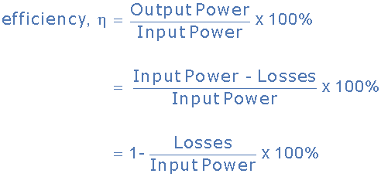

Generally when dealing with transformers, the primary watts are called “volt-amps”, VA to differentiate them from the secondary watts. Then the efficiency equation above can be modified

to:

transformer basics - efficiency

It is sometimes easier to remember the relationship between the transformers input, output and efficiency by using pictures. Here the three quantities of VA, W and η have been superimposed into a triangle giving power in watts at the top with volt-amps and efficiency at the bottom. This arrangement represents the actual position of each quantity in the efficiency formulas.

**2.8 TRANSFORMER CONSTRUCTION OF THE CORE:-**

Generally, the name associated with the construction of a transformer is dependent upon how the primary and secondary windings are wound around the central laminated steel core. The two most common and basic designs of transformer construction are the Closed-coreTransformer and the Shell-core Transformer.

In the “closed-core” type (core form) transformer, the primary and secondary windings are wound outside and surround the core ring. In the “shell type” (shell form) transformer, the primary and secondary windings pass inside the steel magnetic circuit (core) which forms a shell around the windings as shown below.

* **TRANSFORMER CORE CONSTRUCTION:-**

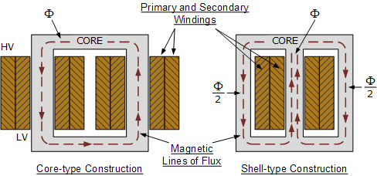

Fig.2.5 TRANSFORMER CORE CONSTRUCTION

In both types of transformer core design, the magnetic flux linking the primary and secondary windings travels entirely within the core with no loss of magnetic flux through air. In the core type transformer construction, one half of each winding is wrapped around each leg (or limb) of the transformers magnetic circuit as shown above.

The coils are not arranged with the primary winding on one leg and the secondary on the other but instead half of the primary winding and half of the secondary winding are placed one over the other concentrically on each leg in order to increase magnetic coupling allowing practically all of the magnetic lines of force go through both the primary and secondary windings at the same time. However, with this type of transformer construction, a small percentage of the magnetic lines of force flow outside of the core, and this is called “leakage flux”.

Shell type transformer cores overcome this leakage flux as both the primary and secondary windings are wound on the same center leg or limb which has twice the cross-sectional area of the two outer limbs. The advantage here is that the magnetic flux has two closed magnetic paths to flow around external to the coils on both left and right hand sides before returning back to the central coils.

This means that the magnetic flux circulating around the outer limbs of this type of transformer construction is equal to Φ/2. As the magnetic flux has a closed path around the coils, this has the advantage of decreasing core losses and increasing overall efficiency.

* **TRANSFORMER LAMINATIONS:-**

But you may be wondering as to how the primary and secondary windings are wound around these laminated iron or steel cores for this types of transformer constructions. The coils are firstly wound on a former which has a cylindrical, rectangular or oval type cross section to suit the construction of the laminated core. In both the shell and core type transformer constructions, in order to mount the coil windings, the individual laminations are stamped or punched out from larger steel sheets and formed into strips of thin steel resembling the letters “E”s and “I”s as shown below.

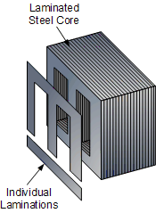

Fig.2.6 TRANSFORMER LAMINATIONS

* **TRANSFORMER CORE TYPES:-**

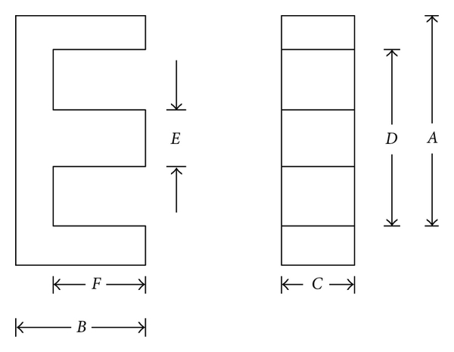

Fig.2.7 TRANSFORMER CORE TYPES

These lamination stampings when connected together form the required core shape. For example, two “E” stampings plus two end closing “I” stampings to give an E-I core forming one element of a standard shell-type transformer core. These individual laminations are tightly butted together during the transformers construction to reduce the reluctance of the air gap at the joints producing a highly saturated magnetic flux density.

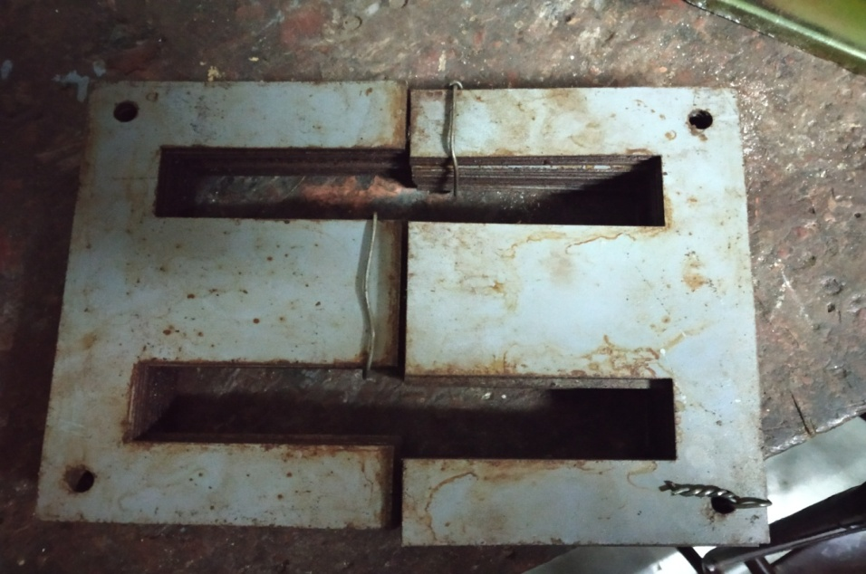

Fig.2.8 E type core

Transformer core laminations are usually stacked alternately to each other to produce an overlapping joint with more lamination pairs being added to make up the correct core thickness. This alternate stacking of the laminations also gives the transformer the advantage of reduced flux leakage and iron losses. E-I core laminated transformer construction is mostly used in isolation transformers, step-up and step-down transformers as well as auto transformers.

* **TRANSFORMER CORE LOSSES:-**

The ability of iron or steel to carry magnetic flux is much greater than it is in air, and this ability to allow magnetic flux to flow is called permeability. Most transformer cores are constructed from low carbon steels which can have permeability’s in the order of 1500 compared with just 1.0 for air.

This means that a steel laminated core can carry a magnetic flux 1500 times better than that of air. However, when a magnetic flux flows in a transformers steel core, two types of losses occur in the steel. One termed “eddy current losses” and the other termed “hysteresis losses”.

* **HYSTERESIS LOSSES:-**

Transformer Hysteresis Losses are caused because of the friction of the molecules against the flow of the magnetic lines of force required to magnetize the core, which are constantly changing in value and direction first in one direction and then the other due to the influence of the sinusoidal supply voltage.

This molecular friction causes heat to be developed which represents an energy loss to the transformer. Excessive heat loss can overtime shorten the life of the insulating materials used in the manufacture of the windings and structures. Therefore, cooling of a transformer is important.

Also, transformers are designed to operate at a particular supply frequency. Lowering the frequency of the supply will result in increased hysteresis and higher temperature in the iron core. So reducing the supply frequency from 60 Hertz to 50 Hertz will raise the amount of hysteresis present, decreased the VA capacity of the transformer.

* **EDDY CURRENT LOSSES:-**

Transformer Eddy Current Losses on the other hand are caused by the flow of circulating currents induced into the steel caused by the flow of the magnetic flux around the core. These circulating currents are generated because to the magnetic flux the core is acting like a single loop of wire. Since the iron core is a good conductor, the eddy currents induced by a solid iron core will be large.

Eddy currents do not contribute anything towards the usefulness of the transformer but instead they oppose the flow of the induced current by acting like a negative force generating resistive heating and power loss within the core.

* **COPPER LOSSES:-**

But there is also another type of energy loss associated with transformers called “copper losses”. Transformer Copper Losses are mainly due to the electrical resistance of the primary and secondary windings. Most transformer coils are made from copper wire which has resistance in Ohms, (Ω). This resistance opposes the magnetizing currents flowing through them.

When a load is connected to the transformers secondary winding, large electrical currents flow in both the primary and the secondary windings, electrical energy and power (or the I2 R) losses occur as heat. Generally copper losses vary with the load current, being almost zero at no-load, and at a maximum at full-load when current flow is at maximum.

A transformers VA rating can be increased by better design and transformer construction to reduce these core and copper losses. Transformers with high voltage and current ratings require conductors of large cross-section to help minimize their copper losses. Increasing the rate of heat dissipation (better cooling) by forced air or oil, or by improving the transformers insulation so that it will withstand higher temperatures can also increase a transformers VA rating.

Then we can define an ideal transformer as having:

* No Hysteresis loops or Hysteresis losses  → 0
* Infinite Resistivity of core material giving zero Eddy current losses  → 0
* Zero winding resistance giving zero I2*R copper losses  → 0

In the next tutorial about Transformers we will look at Transformer Loading of the secondary winding with respect to an electrical load and see the effect a “No-load” and a “ON-load” connected transformer has on the primary winding current.

**3.1 DATA REQUIRED:-**

* **DATA REQURED FOR DESIGNING ISOLATION TRANSFORMER :-**

1. Power rating

2. Voltage levels (primary and secondary)

* **DATA REQURED FOR CONSTRUCTING ISOLATION TRANSFORMER**

1. Currents on both sides
2. Primary and secondary coils wire diameter/size
3. Iron Core area
4. Window area
5. Lamination available
6. Numbers of turns (primary and secondary)

We have designed a 500 VA isolation transformer of 230V to 230V. Necessary calculations along with formulae are given below in details:-

* 1. **CALCULATIONS:-**

1) Calculating the Core Area (Ai) of the Transformer:-

Core area calculated by thumb rule,

Core area (Ai) = 1.15 ×√ VA rating

= 1.151 × 22.36 sq cm

**Ai = 25.736 sq cm**

2) Calculating flux density:-

Standard range flux density is 1 to 1.35 Wb/M2

Selecting flux density Bm = 1 Wb/M2 ,so that iron losses will be less.

Bm = 1.0 wb/Sq.cm

For available CRGO **Bm = 1.3 Wb/Sq.cm**

3) Calculating Turns per Volt (TPV):-

Et = 4.44 × φ × f

= 4.44 × Bm × Ai × f

= 4.44 × 1 × 25.736×10-4 × 50

**Et = 0.571 volt/turn**

So, Turns/Volt = $\frac{1}{Et}$ = $\frac{1}{0.571}$ =1.750

**Turns/Volt = 1.8**

4) Primary Winding Calculations:-

(1) Primary Winding Current IP = V × I

IP= =

**IP = 2.17 Amp $≅$ 2.2 Amp**

From standard table selected gauge wire,

|  |  |  |
| --- | --- | --- |
| Gauge wire | Current rating | Turns per Sq.cm |
| **21 Gauge** | **2.2 Amp** | **137** |

1. Number of primary Turns = Primary Voltage × Turns/volt

= 230 × 1.8

**Number of primary Turns = 414 Turns**

(3) Primary Winding Area = $\frac{Num of primary turns}{turns per Sq.cm}$

= $\frac{414}{137}$

**Primary Winding Area = 3.021 Sq.cm**

1. Secondary Winding Calculations:-
2. Secondary Number of Turns = Secondary Volts × Turns/Volt + 2% extra

= 230 × 1.8 + 2%

**Secondary Number of Turns = 426 Turns**

1. Secondary winding area = $\frac{Number of secondary turns}{Turns per Sq.cm}$

= $\frac{426}{137}$

**Secondary winding area = 3.10 Sq.cm**

(6) Calculating of Core Size for the Steel Laminations or the Stampings:-

1. Total Winding Area = (Primary Winding Area + Total Secondary Winding Area)

= (3.021 + 3.10)

**Total Winding Area = 6.121 Sq.cm**

1. Calculate window area:-

Window area calculated by thumb rule,

Window area = $\frac{Prymary turns}{\sqrt{VA} rating}$

= $\frac{414}{22.36}$

**Window area = 18.5152**

From standard table selected nearest available standard lamination,

|  |  |  |
| --- | --- | --- |
| Type no | Tongue width | Window area |
| **7 ( E-I )** | **5.080** | **18.96** |

1. Gross core area:-

Gross Core Area = $\frac{Core Area }{09}$

= $\frac{25.736}{0.9}$

**Gross Core Area = 28.59 Sq.cm**

1. Calculated tongue width:-

Tongue Width = √Gross Core Area

= $√28.59$

Tongue Width = 5.34 $≅$ 5.080

From standard table selected nearest above standard **tongue width i.e. 5.080**

1. Calculated stack height:-

Stack Height = $\frac{Gross Core Area }{Tongue Width}$

= $\frac{28.59}{5.080}$

**Stack Height = 5.629**

**3.3 DESIGN RESULT**

|  |  |
| --- | --- |
| **Parameters** | **Specification** |
| VA Rating | **500 VA** |
| Voltage | **230V** |
| Current rating | **2 Amp** |
| Gauge wire | **21 SWG** |
| Core area | **25.735 Sq.cm** |
| Flux density | **1 Wb/m2** |
| Turns/volt | **1.8** |
| Primary turns | **414 turns** |
| Secondary turns | **426 turns** |
| Turns per Sq.cm | **137** |
| Window area | **18.96 sq.cm** |
| Lamination type | **7 ( E-I )** |
| Tongue width | **5.080 cm** |
| Gross core area | **28.59 sq.cm** |
| Stack height | **5.629 cm** |
| Primary winding area | **3.021 Sq.cm** |
| Secondary winding area | **.**  **3.10 Sq.cm** |
| Total winding are | **6.121 Sq.cm** |

**4.1 MATERIALS USED IN MANFACTURING :-**

1. **Core** :-

Core:-7 (E-I)Square Stack

Core Size:-2 Inch Stack

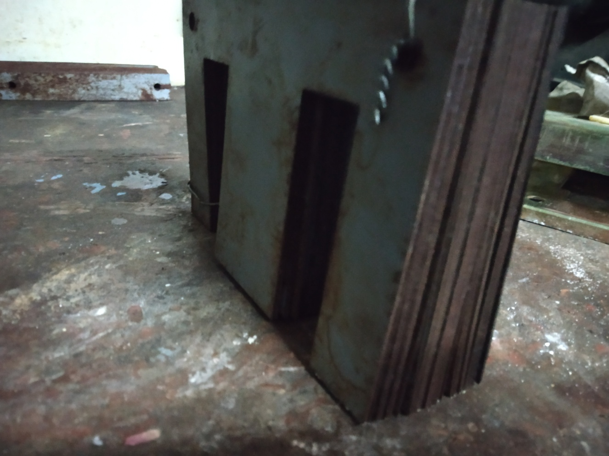

Fig.4.1 core

1. 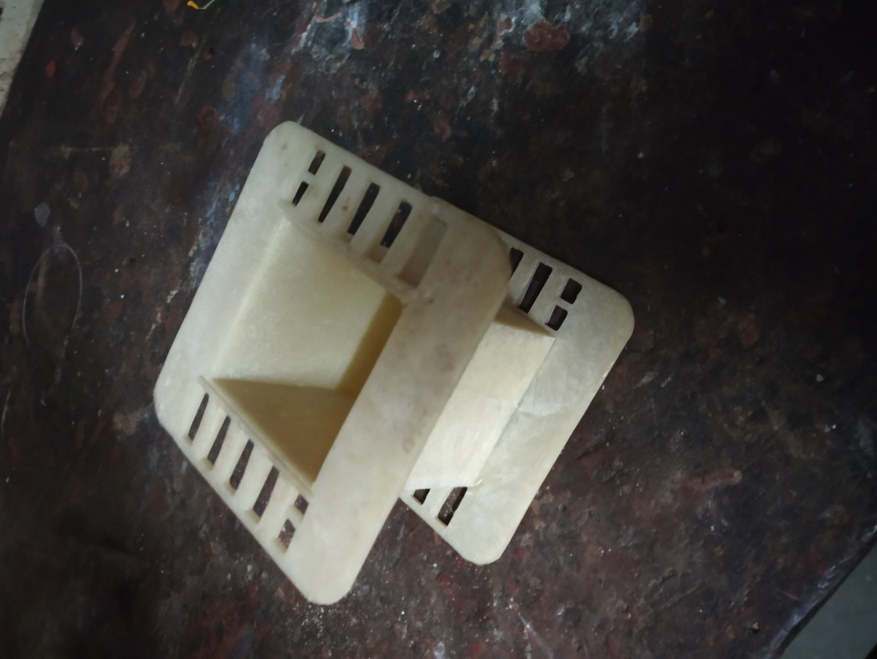**Nylon Bobbin:-**

Fig.4.2 nylon bobbin

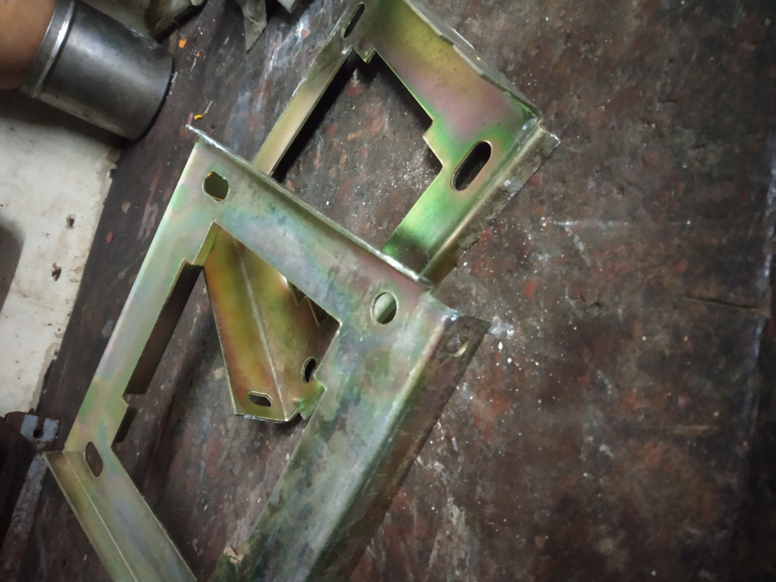

1. **End Clamps (Side Brackets):-**

Fig.4.3 End Clamps (Side Brackets)

1. **21 Gauge Wire:-(1.8 Kg) Approximately-2 Kg**

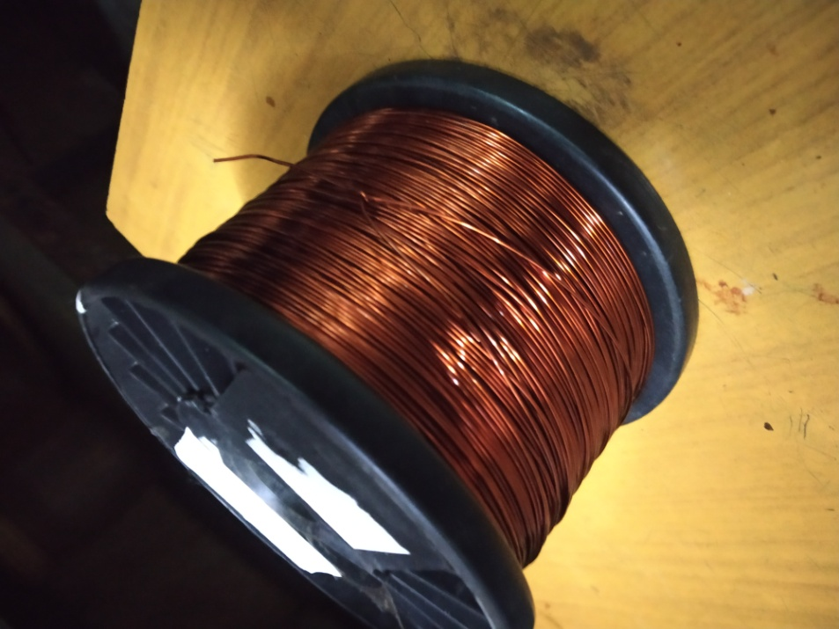

Fig.4.4 21 Gauge Wire

1. **Terminals**:-Fibre Glass Pieces One Is Of 4 Way Terminal Strip & 5 Way Terminal Strip

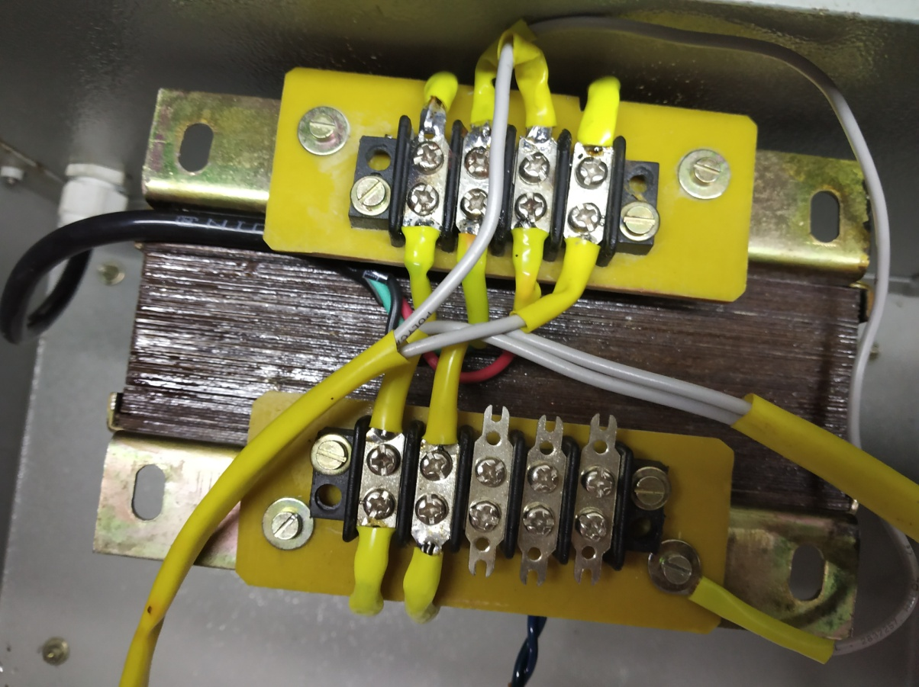

Fig.4.5 Terminals

1. Transformer Varnish:-Baking Into Oven Up to 80 C For 2 Hours
2. Fastener (Nut & Bolts)
3. Hex Side Screw:-3 Inch By ¼ Inch With Nut & Washer

**4.2 MANUFACTURING OF AN ISOLATION TRANSFORMER:-**

We had given step wise procedure of the isolation transformer step by step as follow,

1. Initially we had selected the size of the wire required for our isolation transformer, as per the selection of wire, we had selected the 21 gauge copper wire for required 500VA transformer as respectively we had selected the core of the transformer, which plays the very crucial role in isolation transformer which is the one of the main component of transformer, as per the requirement of the transformer we had selected the size of the core of transformer.Therefore transformer core size is “T Square 34 stacks” after the selection of core step by step we had selected each and every component of the isolation transformer one by one
2. Then it comes to the bobbin as per the the selected schedule we had selected the bobbin size.Size of the bobbin is 43 number. Then we had fixed bobbin in the particular attachtedable equipment bobbin is fixed and then the selected gauge wire is wounded on the bobbin process of winding and wire is as follow,
3. Initially we had wrapped the insulating paper, on the bobbin which is an “leather white paper” which is actually of black colour. Then we started and winding wire on bobbin as we completed the one side of winding , again we added the insulating paper i.e. “leather white paper” this process had continued for two and fro still we completes the primary side of winding that is wounded by 414 turns in primary side of the transformer.
4. Then again we attached the leather wide paper and repeated the same process of winding for secondary side of winding we had wounded an 426 turns on the secondary side of the transformer.
5. After completion of the winding process we started the stamping process of an isolation transformer. Stamping process contains an E piece and I piece size of the e and I piece is T34, so we added E piece from one side and I piece from another side of it. Alternatingly the process continue till it gets completely pack that is we added E n I piece tightly till it gets filled then we adjusted each piece to see wether there is any gap or not in it , then we just hammered it lightly in order to adjust them in order, after that we fixed and End clam brackets and get tighter that end clam bracket with screw and nuts , then it complets our stamping process , then it comes to the next process of the transformer that is varnishing process of isolation transformer.
6. Then we deeped the isolation transformer into the varnishing liquid directly for 6 hours colour of the varnish was brownish and after the complete deeping process of it be removed it out from liquid and kept it on the iron grill for 2 hours so that the unwanted varnish gets drip away then be baked it into the oven at 80 ˚c for 4 hours after that we dried it.
7. This has completed the our process of main manufacturing then we decided the cabinate of the transformer and had modified the cabinate from workshop where we had done drilling n cutting of the box as per the requirement then we decide the minor components of the transformer that is terminals, display, MCB, toggle switch, 5amp socket etc. and arranged them accordingly as per the requirement.

**5.1 TESTING OF TRANSFORMER AS PER IS 2026:-**

* Routine test:-

1. Winding resistance measurement test
2. Insulation resistance measurement test
3. High voltage test
4. Open circuit test
5. Short circuit test
6. Polarity test
7. Phasing out test
8. Voltage ratio test
9. Vector group

* Type test:-

All routine test

10. Temperature rise test

11. Impulse test

* Special test:-

1 .Measurement of harmonics in induced voltage

2. Measurement of zero phase sequence impedance

3. Measurement of noise level

* 1. **NSTESTING OF ISOLATION TRAFORMER:-**

1. Insulation Resistance Measurement Test
2. Winding Resistance Measurement
3. Voltage Ratio Test
4. Direct Load Test
5. Open Circuit Test

* **TESTING OF ISOLATION TRANSFORMER**:-

**1. INSULATION RESISTANE MEASUREMENT TEST:-**

The insulation resistance test second test required by the electrical safety testing standard. The insulation resistance of motor is resistance between one of the conductor path and earth resistance between two separate conducting paths.

**CIRCUIT DIAGRAM:-**

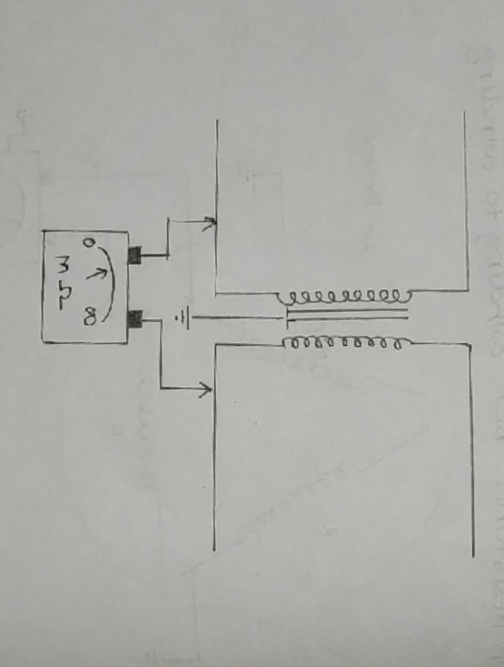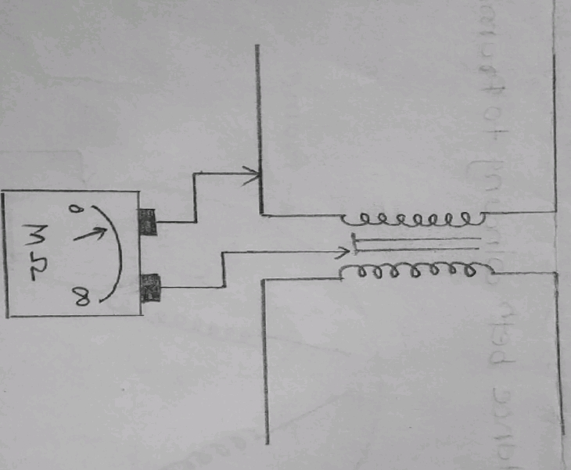

Fig.5.1 measurement of winding & winding fig.5.2 measurement of winding & core

**OBSERVATION TABLE:-**

|  |  |  |  |
| --- | --- | --- | --- |
| Test | Value Of Resistance Measured In MΩ | | |
| Insulation Resistance | Primary winding and frame | Secondary winding and frame | Primary & secondary |
| 1000Ω | 1000Ω | 1000Ω |

**2. Winding resistance measurement:-**

**DIAGRAM:-**

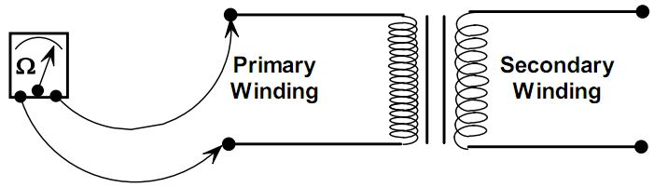

Fig.5.3 Winding resistance measurement

**OBSERVATION TABLE:-**

|  |  |
| --- | --- |
| Primary Winding In Ω | Secondary Winding In Ω |
| 3.4 | 4.2 |

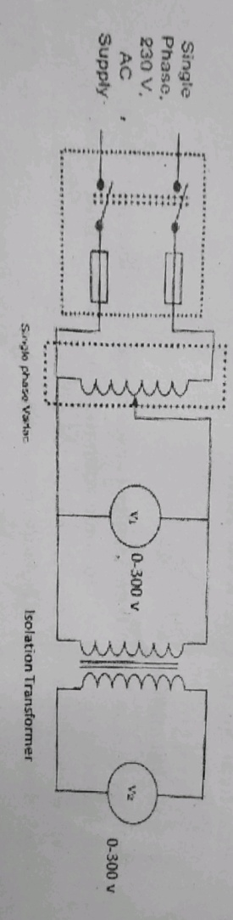**3. VOLTAGE RATIO TEST:-**

To measure voltage ratio test one winding to another associated winding .

**CIRCUIT DIAGRAM:-**

Fig.5.4 VOLTAGE RATIO TEST

**OBSERVATION TABLE:-**

|  |  |  |
| --- | --- | --- |
| Primary Voltage (V1) | Secondary Voltage  (V2) | Voltage Ratio  V1/V2 |
| 50 | 52 | 0.961 |
| 100 | 103 | 0.970 |
| 150 | 154 | 0.974 |
| 200 | 206 | 0.970 |
| 230 | 235 | 0.978 |

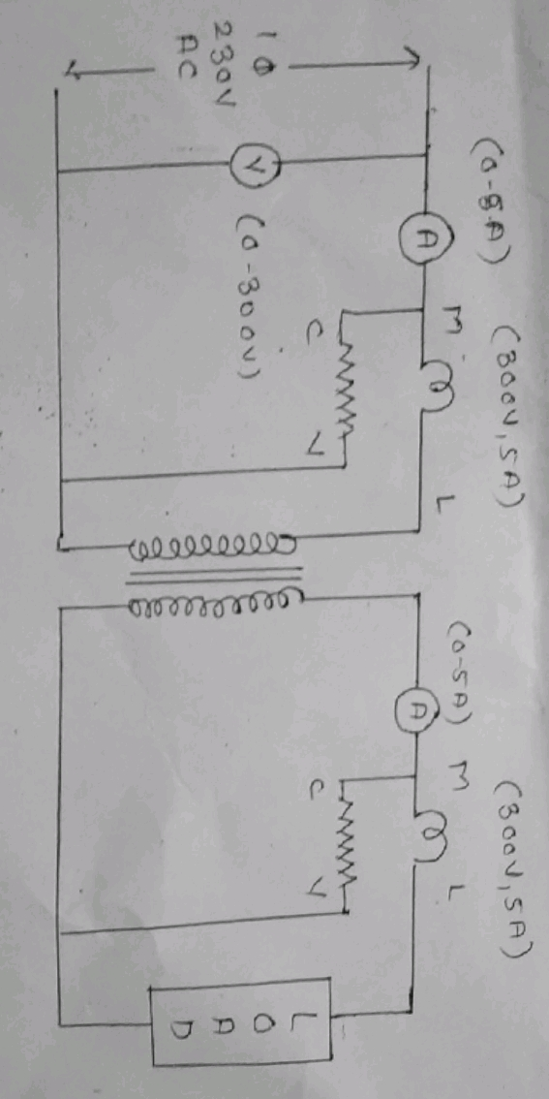**4. DIRECT LOAD TEST:-**

**CIRCUIT DIAGRAM:-**

Fig.5.5 DIRECT LOAD TEST

**OBSERVATION TABLE:-**

|  |  |  |  |  |  |
| --- | --- | --- | --- | --- | --- |
| Sr.No | Primary voltage | Primary current | Secondary Current | Wattmeter (W1) | Wattmeter (W2) |
| 1. | No load  230 | 0.6 | 0.1 | 50 | 45 |
| 2. | 230 | 1.4 | 1.2 | 140 | 120 |
| 3. | 230 | 1.43 | 1.25 | 150 | 130 |
| 4. | Full load  230 | 2.05 | 2.2 | 230 | 205 |

% Voltage Regulation = No load Voltage – Full load voltage × 100

Full load voltage

= $\frac{241-223}{223}$ × 100

= 8.07 %

% Efficiency = $\frac{output}{input}$ × 100

= $\frac{205}{230}$ × 100

= 89.1 %

1. **OPEN CIRCUIT TEST:-**

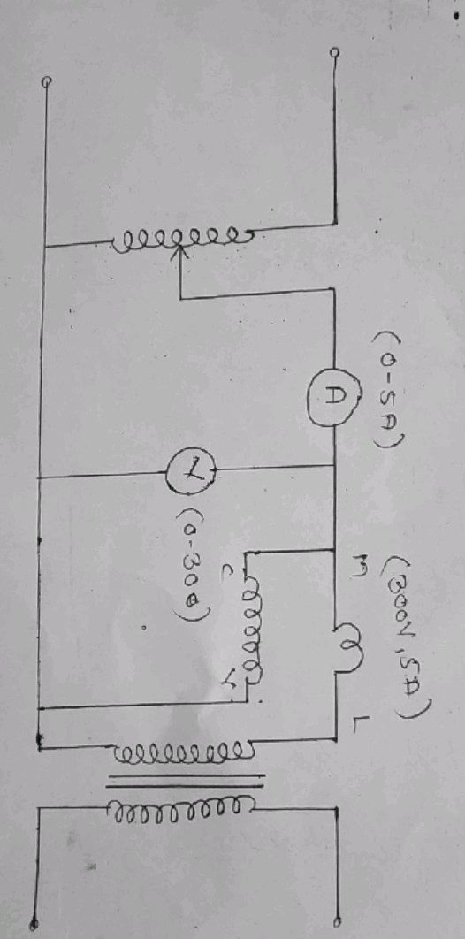This test is performed to measure core loss but core loss depend on power factor of flux density so form factor has to be checked. Supply voltage may not be exactly sinusoidal it contains harmonics similar core cross-section may be inadequate so may get saturated which may introduced harmonics in EMF so wattmeter reading will not give correct core loss so correction is required for this purpose two voltmeter are connected.

**CIRCUIT DIAGRAM:-**

Fig 5.6 OPEN CIRCUIT TEST

**OBSERVATION TABLE:-**

|  |  |  |
| --- | --- | --- |
| Current (I) | Voltage(V) | Wattmeter(W) |
| 230 | 0.31 | 19.2 |

**5.3 RESULT:-**

|  |  |
| --- | --- |
| **Parameter** | **Result** |
| Primary Winding In Ω | 3.4 |
| Secondary Winding In Ω | 4.2 |
| Primary voltage | 230 |
| Secondary voltage | 235 |
| Voltage ratio | 0.978 |
| % Voltage Regulation | 8.07% |
| % Efficiency | 89.1% |

**6.1 ESTIMATION & COSTING:-**

|  |  |  |
| --- | --- | --- |
| Sr.No. | Material | Cost |
| 1 | Core T43 =7 Kg*100 | 800/- |
| 2 | Wire 1.8 Kg = 675*1.8 | 1215/- |
| 3 | End Bracket’s =150 Pair | 150/- |
| 4 | Fastner =10 Rs per piece =10*4 | 40/- |
| 5 | Warnish | 250/- |
| 6 | Backing in oven (supply 1 Kw for 2 Hrs. ) | 50/- |
| 7 | Winding charge | 250/- |
| 8 | Cabinate with cabinate handale (size =HS=100mm) | 1600/- |
| 9 | MCB(4 Amp) | 180/- |
| 10 | Voltmeter (AME) Automatic Electric Meter | 800/- |
| 11 | Toggle switch | 90/- |
| 12 | Socket | 30/- |
| 13 | Terminals | 50/- |
| 14 | LED (10mm) = 2 | 50/- |
| 15 | Main wire | 100/- |
| 16 | Bushing | 40/- |
| 17 | M3/ into 25mm = 8 number screw | 20/- |
| 18 | M6/ into 25mm = 4 number nut bolte with washar | 20/- |
| 19 | Wire,lus,living | 80/- |
| 20 | sholdring | 30/- |
| 21 | Overhade charge (other charge) | 1000/- |
| Total cost | | 6845/- |

**7.1 TROUBLE SHOOTING OF ISOLATION TRANSFORMER:-**

|  |  |  |  |
| --- | --- | --- | --- |
| Sr no. | Trouble | Possible fault | Remedies |
| 1. | No output of isolation transformer | 1. No supply voltage 2. Open in winding 3. Loose tern 4. Display not working | 1. Check and restart the supply 2. Check connection of winding and rectified |
| 2. | Less output | 1. Less input voltage 2. Wimding may be shorted | 1. Check and adjust rated voltage 2. Check shorted turn of both winding |
| 3. | Transformer body receives shock | 1. Any conductor may touch body | 1. Check earthing connection |
| 4. | Over heating | 1. No proper cooling 2. Over voltage 3. .Over current | 1. Check cooling system 2. Check rated voltage 3. Check load current and reduced load |

**8.1 FUTURE EXPANTION:-**

* FUTURE EXPANSION OF ISOLATION TRANSFORMER.

As we conducted various tests on Isolation transformer, Efficiency of Isolation transformer is 80%.

We can improve the efficiency of the transformer up to 90%, By Adopting the various methods such as,

* **Selection of proper Core and Core Material**:-used CRGO core which reduces flux leakage in transformer.
* **Selection of proper wire & material**: - used superior wire material which reduced losses in transformer.
* **Reduce the losses in the transformer**: - to reduce losses in the transformer we can used energy efficient materials.
* **Periodical maintenance: -** Maintenance schedule of transformer includes daily, weekly, monthly, quarterly, half early, early and once in 2-3 years. This periodical schedule should be well planned and followed strictly routine maintenance helps to increases performance of the transformer.
* **By providing cooling system: -** No transformer is truly an '[ideal transformer](http://www.electricaleasy.com/2014/03/ideal-transformer-characteristics.html)' and hence each will incur some [losses](http://www.electricaleasy.com/2014/04/transformer-losses-and-efficiency.html), most of which get converted into heat. If this heat is not dissipated properly, the excess temperature in transformer may cause serious problems like insulation failure. It is obvious that transformer needs a cooling system. Transformers can be divided in two types as:-

1. Dry type transformers
2. Oil immersed transformers.

Different cooling methods of transformers are –

For dry type transformers.

* Air Natural (AN)
* Air Blast

**9.1 SAFETY PRECAUTION:-**

Isolation transformers make working on AC equipment safer and can protect against unintentionally introducing shorts in the circuit. Working on the principle of mutual induction, they are used to break ground loops and remove unintended current paths where accidental contact could cause problems.  When choosing an isolation transformer, select one with appropriate ratings and specs for your requirements.

* **IMPORTANT SAFETY INSTRUCTIONS:-**

Before installing or using this product, please read and save the safety instructions below.

1. **GENERAL SAFETY PRECAUTIONS:-**
   * 1. Do not expose the isolation transformer to water, mist, snow, spray, or dust.
     2. Do not use the product where there is a risk of gas or dust explosions. This product is not ignition protected.
     3. Use the product in accordance with specifications as stated in paragraph 4.
     4. Do not open the enclosure if the product is still connected to a source of electrical power.
2. **SAFETY: INSTALLATION:-**
3. Connections and safety features must be according to the locally applicable regulations.
4. This is a Safety Class 1 product (supplied with a protective grounding terminal). Uninterruptible protective grounding must be provided.
5. Use electric cables of the appropriate size.
6. Install the isolation transformer in a well-ventilated area.
7. Keep a clear space of 10 cm around the product for ventilation.
8. For safety purposes, the product should be installed in a heat-resistant environment. Avoid the presence of e.g. chemicals, synthetic components, curtains or other textiles in the immediate vicinity of the product.

**10.1 REFREANCES:-**

* **Website:-**
* dpi-proceedings.com
* [www.researchgate.net](http://www.researchgate.net)
* en.wikipedia.org
* uk.farnell.com
* www.quora.com
* **Handbook:-**
* Practical Transformer Design Handbook- By BPB Publication, by Eric Lowdon.
* Maintenance Handbook on Transformer, by A.R.Tupe.
* [Transformer and Inductor Design Handbook (Ele…](https://www.amazon.com/dp/1439836876/ref=rdr_ext_tmb)(Hardcover),by [Colonel Wm. T. McLyman](https://www.amazon.com/s/ref=rdr_ext_aut?_encoding=UTF8&index=books&field-author=Colonel%20Wm.%20T.%20McLyman)
* **Reference book:-**
* Dc Machines and Transformers, by K Murugesh Kumar
* Design of transformer, by Indrajit Dasgupta
* Ieema journal – Electrical Publication
* **Industrial support:-**
* Ravi enterprises, thane.

**11.1 Appendix:-**

